GENERAL INFORMATION
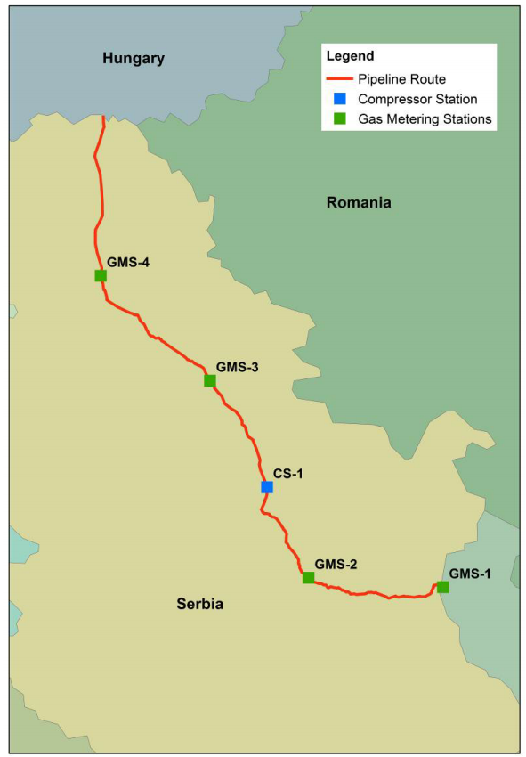
The new DN 1200 (48”) Gas Pipeline on the territory of Serbia from the border with Bulgaria (the cross-border point is located near Zaječar) to the border with Hungary (the cross-border point is located near Horgoš) is intended to deliver specified gas flowrates to the following delivery points connected to the Serbian network:
The technical (firm) capacity of GMS-2 (Paracin) is 1.95 mcm/d = 0.71 bcm/y (at Standard reference conditions*);
The technical (firm) capacity of GMS-3 (Pancevo) is 3.70 mcm/d = 1.35 bcm/y (at Standard reference conditions*);
The technical (firm) capacity of GMS-4 (Gospodjinci) is 5.64 mcm/d = 2.06 bcm/y (at Standard reference conditions*).
The technical (firm) capacity of the IP Serbia is 11.29 mcm/d = 4.12 bcm/y (at Standard reference conditions*).
The technical (firm) capacity of the IP Kireevo/Zajecar (Bulgarian/Serbian border) for the direction Bulgaria to Serbia, on Serbia side, is 35.26 mcm/d = 12.87 bcm/y (at Standard reference conditions*).
The technical (firm) capacity of the IP Kiskundorozsma 1200 (Serbian/Hungarian border) shall be for the direction of Serbia to Hungary 16.44 mcm/d = 6.00 bcm/y (at Standard reference conditions*).
* Standard reference conditions of temperature, pressure and humidity to be used for measurement and calculations on natural gas are 293.15 K (=20℃) and 101.325 kPa (=1.01325 bar (absolute)) for real dry gas.

All required facilities pipeline, gas metering stations, branch pipelines (to connect the main pipeline to relevant GMS for gas delivery to the existing Serbian network), block valves, pig launchers/receivers, auxiliary facilities, etc.) are provided. The compressor station will be provided.
The Project has been structured in the following functional elements:
• Pipeline
The Pipeline is divided into 4 sections:
- Section 1: from the Bulgarian/Serbian border (near Zaječar) to Žabari, total length about 147 km (from 0 km to 147,012 km),
- Section 2: from Žabari to Kovin total length about 48 km (from 150 km to 197,768 km),
- Section 3: from Kovin to Gospodjinci total length about 112 km (from 198 km to 310,072 km),
- Section 4: from Gospodjinci to the Serbian/Hungarian border (near Horgoš) total length about 92 km (from 310,100 km to 402,069 km).
• BVSs
Within these sections, 18 BVS (block valve stations) were made.
• GMSs
Within these sections the following n. 4 GMSs are envisaged:
- GMS-1 (km 0,257) on the Bulgaria/Serbia border near Zaječar (KО Prlita);
- GMS-2 (km 84,134) with the branch pipeline near Paraćin (Cadastral Municipality Bošnjane);
- GMS-3 (km 217,717) on the branch pipeline near Pančevo (Cadastral Municipality Pančevo);
- GMS-4 (km 309,612) on the branch pipeline near Žabalj, Cadastral Municipality Žabalj.
GMSs located on pipeline branches to Serbian System (GMS-2, GMS-3) are provided with a pressure reduction system. The pressure will be reduced to a level not higher than 45barg. Commercial flow measurement and gas analyzer to evaluate chemical and physical properties (quality) of the gas are provided on each GMS. Auxiliary facilities for Metering Stations operability assurance are also included.
• Compressor Station CS-1
А compressor station is provided (near Velika Plana, km 144,666), including auxiliary facilities.

Our AFOs are:
-on IP Kireevo/Zajecar (Bulgarian/Serbian border) - BULGARTRANSGAZ EAD
-on IP Serbia - TRANSPORTGAS SRBIJA d.o.o.
-on IP Kiskundorozsma 1200 (Serbian/Hungarian border) - FGSZ Ltd.

