Exchange of information about users
Gastrans will provide the adjacent TSO with a list of user codes that users will use when nominating quantities of natural gas for transport by the Gastrans transport system. Also, the adjacent system operators will submit to Gastrans a list of user codes that users will use when nominating quantities of natural gas for the needs of transport by the transport system of adjacent system operators.
Information exchange in the nomination and matching process
Users of the system in the nomination process inform their TSO about the quantities of gas they intend to transport, via the NOMINIT form, which they submit to the TSO no later than 14.00h on the gas day preceding the gas day to which the nomination refers (D-1).
The initiating TSO notifies the adjacent TSO of the announced quantities of gas, via the DELORD form, no later than 14.45h on the gas day preceding the gas day to which the nomination refers (D-1).
The matching TSO notifies the adjacent TSO of the confirmed gas quantities, via the DELRES form, no later than 45 minutes after receiving the DELORD from the initiating TSO.
TSOs confirms the nominated quantities to its users via the NOMRES form, no later than 16.00h on the gas day preceding the gas day to which the nomination refers (D-1).
Tabular presentation of pairing processes and time frames:
At Interconnection point (IP) Kireevo / Zajecar
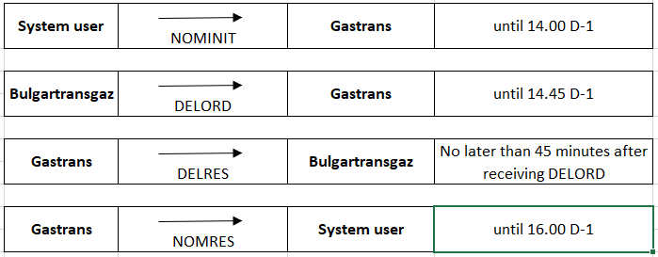
At IP Srbija
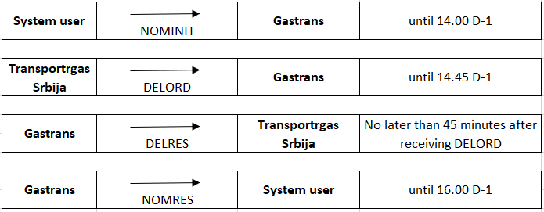
* There is currently no natural gas transportation at IP Kiskundoroszma 1200
Allocation of natural gas quantities
The allocation of quantities delivered and / or taken over by the relevant Network User will be carried out on the basis of harmonized - matched quantities. The unit of allocated quantity is kWh (25°C / 0°C). The daily allocation report, which contains information of the daily quantities and related data on the Gross Calorific Value (25°C / 0°C), will be sent by Gastrans to Bulgartransgaz and Transportgas Srbija.
Allocated daily quantities for Users represent the last matched quantities in kWh.
The total quantity of gas delivered during one month will be determined by the 5th working day of the following month, based on daily gas quantity reports containing updated daily quantities and data on Gross Calorific Value (25°C / 0°C). The official unit is kWh (25°C / 0°C).
O.B.A.
With the introduction of the Operational Balancing Account (OBA) and close cooperation regarding flow management, the adjacent TSOs aim to allocate the quantities of gas, which have been appropriately nominated and confirmed, to the Network Users without interruptions and reductions.
Any imbalance resulting from the difference between the measured quantities for a given gas day and the quantities from the matched daily delivery plan for the same gas day will result in an operational imbalance that will be charged or credited to the goods in the OBA, as defined by mutual Interconnection Agreement of two adjacent operators.
At the beginning of the introduction of the OBA, the TSOs are obliged to maintain the value of the cumulative imbalance registered on the operating balance that does not exceed the limit set by the adjacent TSOs.
At IP Kireevo / Zaychar, for the period until 30.09.2021. the operators set a limit of +/- 3.8 GWh, after which the subject limit will be expanded to +/- 15 GWh.
At IP Serbia, the operators have set a limit of +/- 5 GWh.
In case of overrun OBA limit, the adjacent TSOs are obliged to correct it no later than 10 days after the planned limit has been exceeded. The rule applies to IP Serbia and IP Kireevo / Zaychar that if the adjacent TSOs agree operationally, one of the two activities can be applied:
1. Temporary expand of the value of the cumulative imbalance, which means defining the levels of expansion and the expected duration. The adjacent TSOs will return the temporarily extended value of the cumulative imbalance to the previously agreed level at the agreed time, whereby the temporary extension ceases to be valid.
2. Temporary suspension of the application of the OBA. If the cumulative imbalance exceeds the agreed limits, either party may suspend the application of the OBA, whereby the allocation of user quantities would be done by the proportional method. All delivered / taken over energy would be allocated to the users, in proportion to the participation of the confirmed nominations of each user in the sum of all confirmed nominations.
* There is currently no natural gas transportation at IP Kiskundoroszma 1200, so the rules for the realization of the OBA have not been defined yet.
Gas quality
The quality requirements for gas transported by the Pipeline are determined in accordance with the official regulations. The transporter takes over the natural gas made available by the user at the contracted entry point which is in accordance with the prescribed gas quality and the transporter delivers to the user at the contracted exit point gas which is in accordance with the prescribed gas quality. If the gas delivered by the user at the contracted entry point does not meet the prescribed quality requirements of natural gas, the transporter may refuse to take over gas that deviates from the prescribed quality, in whole or in part. The transporter shall endeavor to take over gas that deviates from the prescribed quality if the takeover of such gas does not endanger the safety and / or integrity of the transmission system. The right to compensation for damage that occurs in the case of delivery of gas that does not correspond to the prescribed quality and the manner of exercising this right is regulated in the Long-Term agreement on access to the system and transportation of natural gas and Short-Term agreement on access to the system and transportation of natural gas. The specification of natural gas quality is given below.

Chemical composition | Mol percent
Methane (C1) | Minimum 92
Ethane (C2) | Maximum 4
Propane (C3) | Maximum 2
Butane (C4) | Maximum 1,5
Pentane (C5+) | Maximum 0,5
Hexane | Maximum 0,2
Nitrogen (N2) | Maximum 2
Carbon dioxide (CO2) | Maximum 1
Oxigen (O2) | Maximum 0,02
Gross calorific value (kWh/m3) | 10.80 – 12.20
Wobbe indeks (kWh/m3) | 13.59 - 15.37

